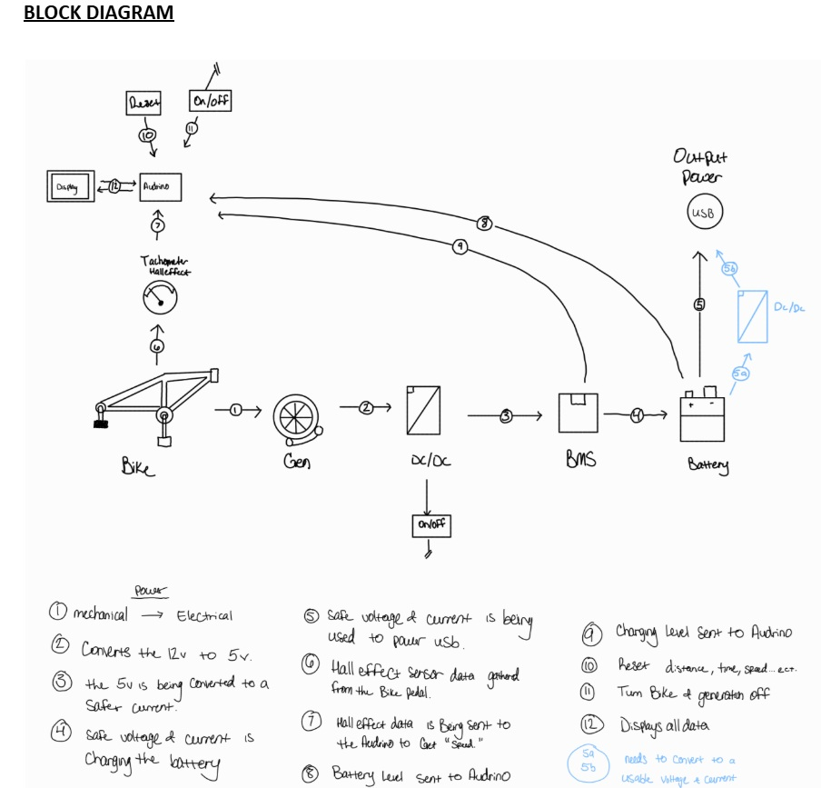

Decisions made:

* DC motor selected for easier use
* Atmega328P microcontroller selected to control the operation
* Two buck-boost converters will be used
* I2C, 8bit parallel communication from microcontroller and peripherals
* Internal comparator and external op amp used for reading motor rotation and power generation for cost reduction.
* All active components will be powered by the internal battery to not draw power from the unfiltered DC generated power.
* Soft latch circuit to turn on the device or off
* 1602 LCD screen selected for ease of programming
* SparkFun Battery Babysitter and Adafruit TPS63060 selected for the battery charging
* Hand crank with gear ratio for proof of concept prototype for the power generation